Circle Language Spec: Interfaces

Interface Assignment Types
This section is a mere supplement to the Assignment articles in the System Objects chapter. For a general explanation of assignment, look there. This section only makes the Interface aspect catch up with the rest of the explanations.

Interface Assignment
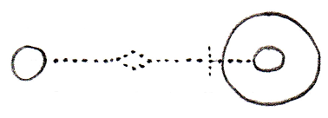
Use As Interface ← (~= Object Get)
Interface Set →
Makes the source become
the interface for the target.
Interface Pointer Assignment
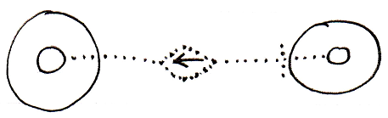
Use Reference As Interface ← (~= Reference Get)
Interface Set → (~= Set Interface to Other Related Item)
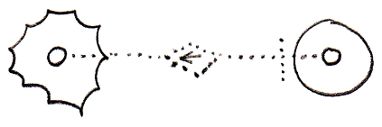
Use Reference As Interface ← (~= Reference Get)
Interface Set → (~= Set Interface to Other Related List Item)
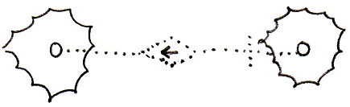
Use Reference As Interface ← (~= Reference Get)
Interface Set → (~= Set Interface to Other Related List Item)
Interface Assignment With Pointer Source
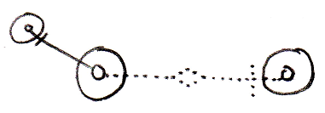
Use As Interface ← (~= Use Reference As Interface)
Interface Set → (~= Set Interface to Other Related Item)
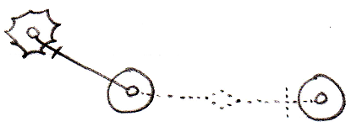
Use As Interface ← (~= Use Reference As Interface)
Interface Set → (~= Set Interface to Other Related List Item)
Cross-Aspect Interface Assignment
Object-Interface to Object Assignment
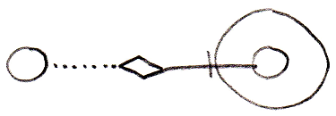
Object-Interface Get ←
Object Set →
Reference-Interface to Object Assignment
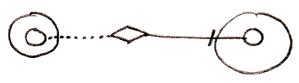
Reference-Interface Get ←
Object Set →
Object-Interface to Reference-Class Assignment
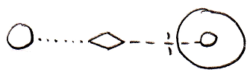
Object-Interface Get ←
Reference-Class Set →
Object-Class to Reference-Interface Assignment
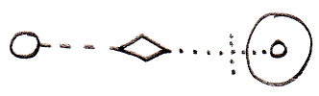
Object-Class Get ←
Reference-Interface Set →
Reference-Class to Reference-Interface Assignment

Reference-Class Get ←
Reference-Interface Set →

There are more implementations of the cross-aspect assignments for cases when the source of the assignment is a pointer-to-pointer, but they are not shown here. To understand the concept look in the Cross-Aspect Assignments article in the System Objects chapter.

In Text Code
If you must have a character symbol for a class assignment, that distinguishes it from the other assignment types, it is the following symbol:

i=

This symbol is the identifier for interface assignment. The letter i stands for interface.

The textual symbol for an interface pointer assignment is:

i=→

It can be pronounced ‘interface is pointer to’
In an actual text code line it would look like this:

A i=→ B

It can be pronounced ‘A interface is pointer to B’.

